**Movement test result 10/30/17**

1. Approver remarks did not reflect after saving/approval

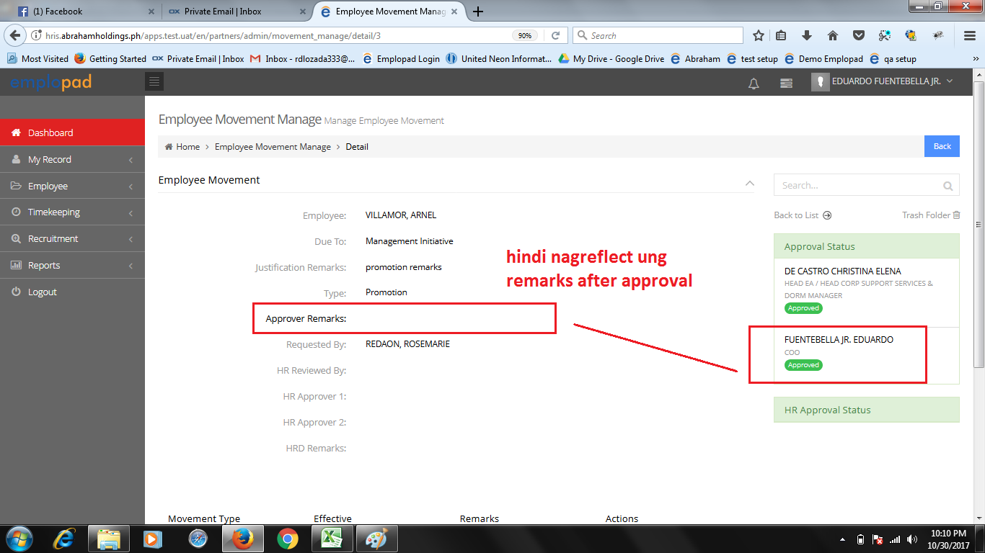

Panopala view paglahatng approver nag remarks. Each approver kase may remarks field.

Ok na ito. lahat ng approver and remarks nila makikita mo. Pababa lang display niya.

1. No system notification created for HR recruitment staff that there is an approved movement request.**(33013 -CAMILLE JELA MAE D. LLOREN)**

Paps kaya wala siya na recive kasi yong role niya (HR Administrator w/ Payroll - KHP, TLP, ITH, SIMCHA, TIC) tapos itong (Role Setup for Subordinates Access Limitation) di nakalagay yong company niya na AHI.

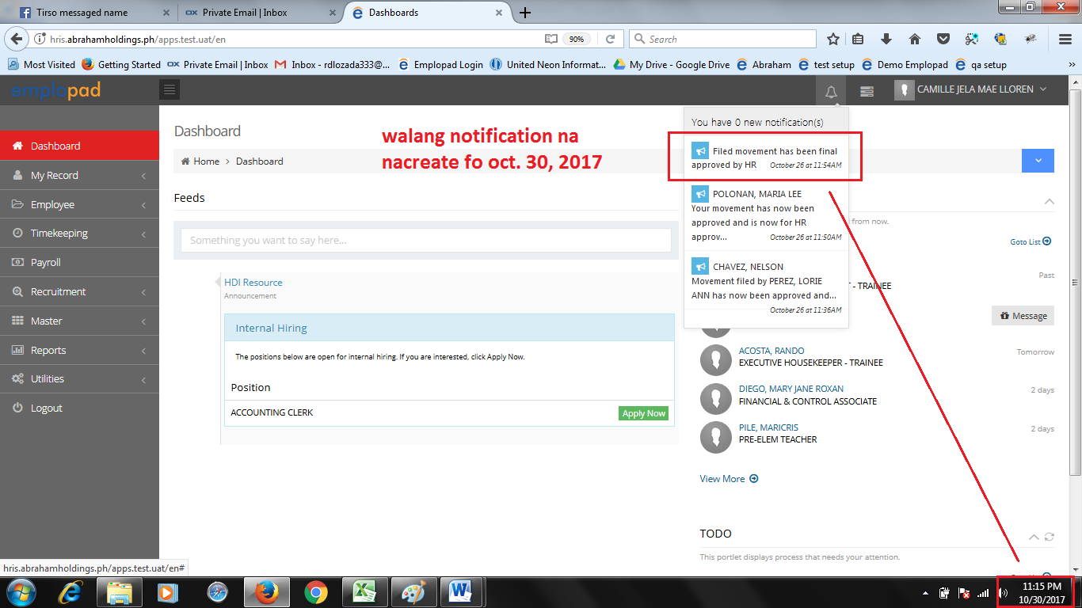

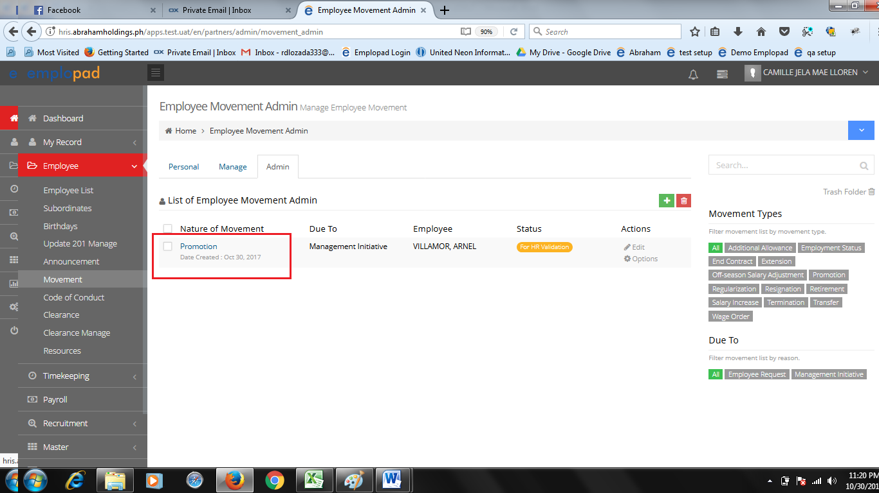Ito ung approved movement nawalang notification sahr recruitment staff

Per kams. Lee meronna-create na email notification. (hindiba setup itopaps?)

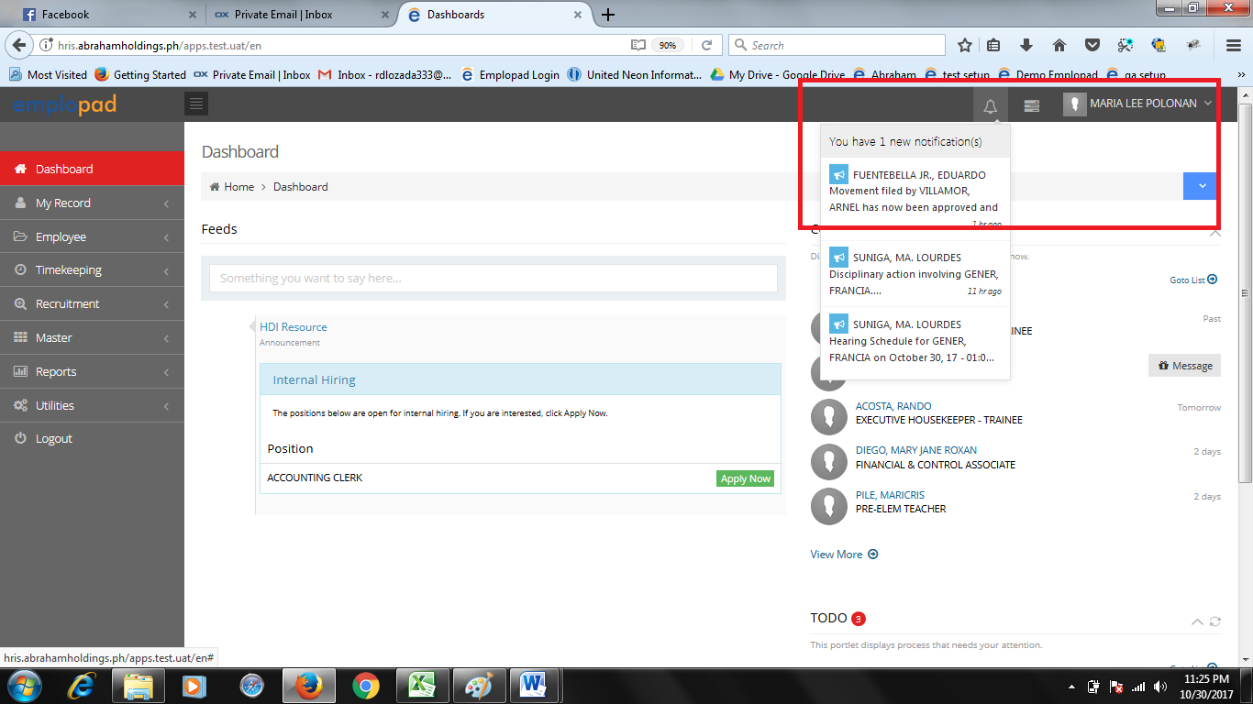

1. Admin tab (nature of movement)

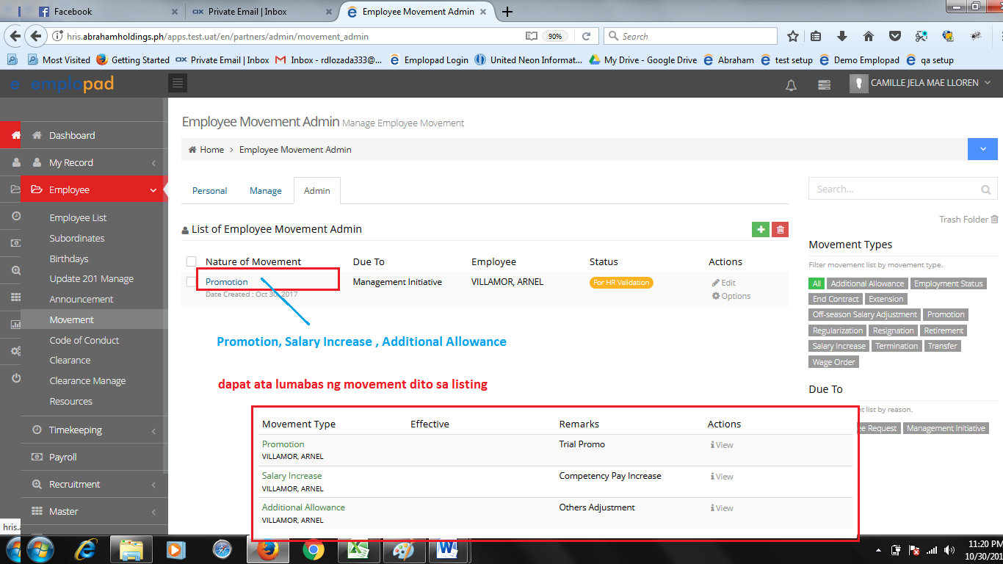

1. HR Approver (Ms.lee) walang entry ng remarks pag disapproved?

Wala talaga itong hr approver remarks, kasi manual approval yong ginawa natin dito hindi ito katulad noon dumaan sa approver. Simula pa lang noon pinagawa nila ito wala na talaga remarks ito

Ok na ito. Dapat yong gumawa lang yong papadalhan, kasi nag base lang ako doon sa personal dati. So kung yong mismo tao yong gumawa siya papadalhan, kung yong immediate siya papadalhan.

1. 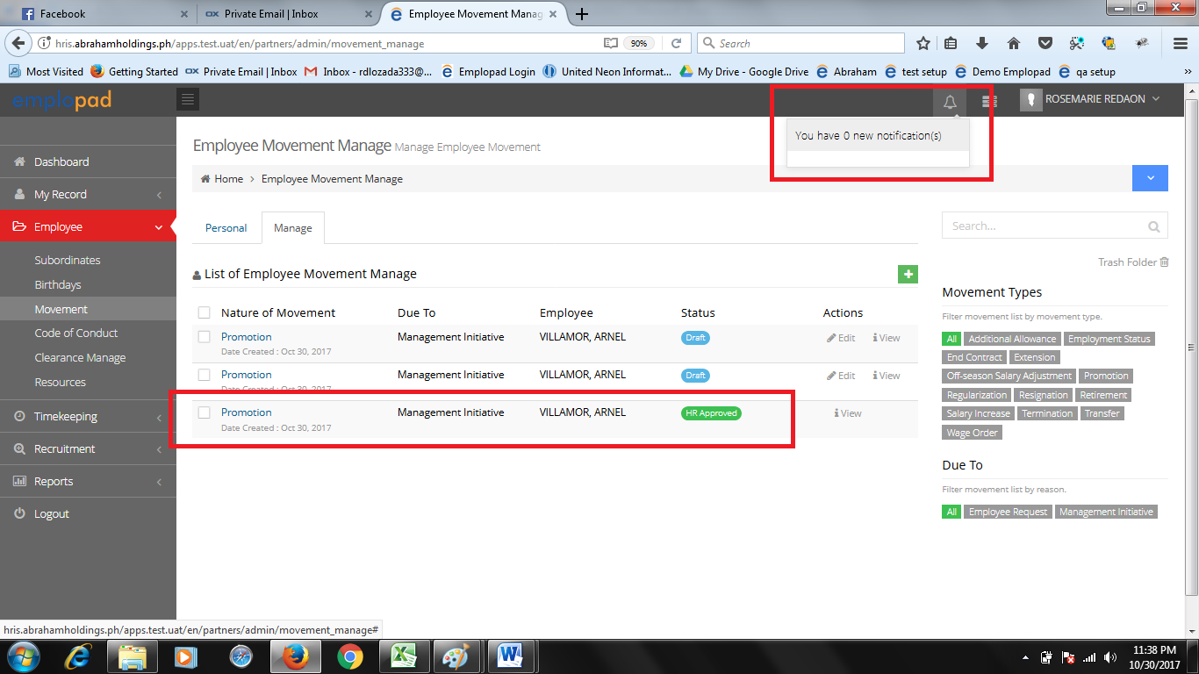Walang notification kay requestor (immediate sup) na approved nan g h rung movement request parasataonya.

Server time nila yan. Pwede natin pa setup sa kanila yan kapag nagpunta tayo

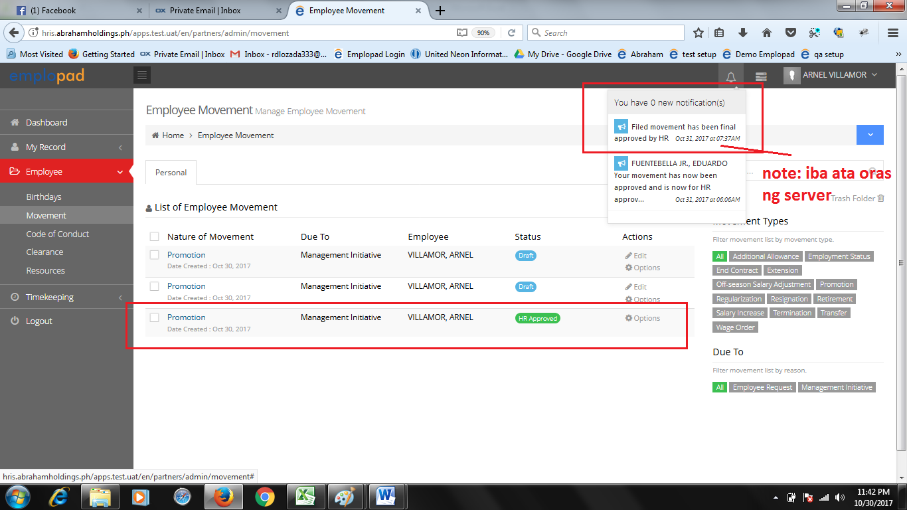Peromeron notification sataonaginawanng movement.